For Centre for Innovation & Consultation Use Only:
REF. NO:
CENTRE FOR INNOVATION & CONSULTATION
(PUSAT INOVASI & PERUNDINGAN)
TEL: 604-653 6530/6510 FAX: 604-653 6500

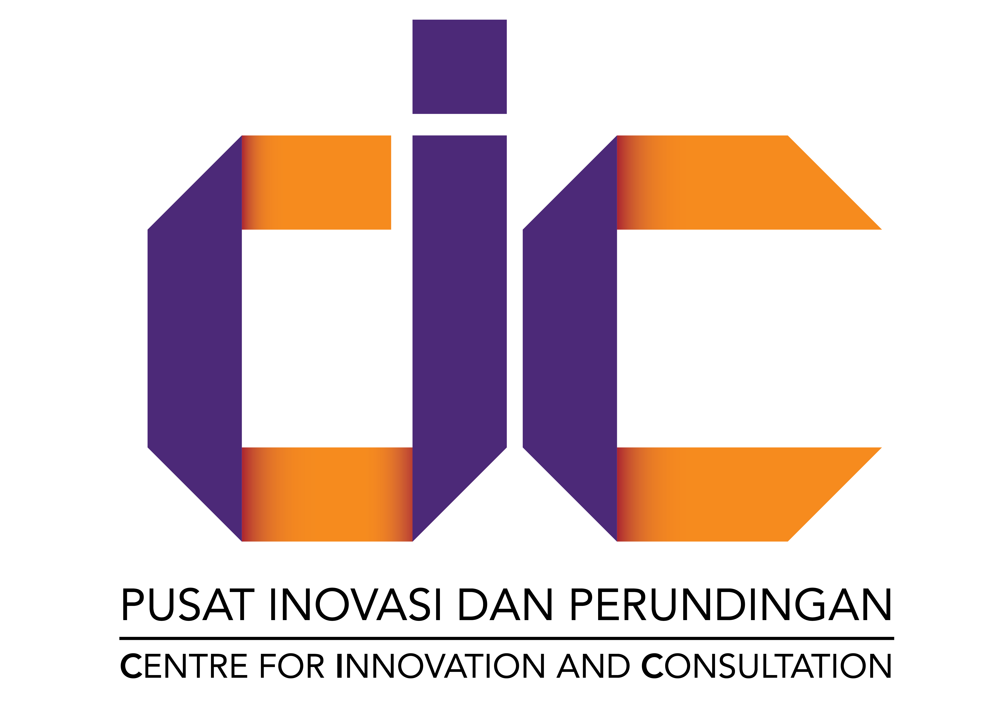

INVENTION DISCLOSURE FORM (IDF)
(BORANG PENDEDAHAN REKACIPTA)

1. | PERSONAL INFORMATION OF INVENTOR(S) / MAKLUMAT PEREKA

Name of Principal Inventor Maklumat Ketua Pereka
Designation
Jawatan
School/Centre/Department
Pusat Pengajian/Pusat/Jabatan
Nationality  Kewarganegaraan |  | IC/ Passport No.  No. IC/ Pasport
Telephone No.
No. Telefon
Fax No.
No. Faks
Email
E-mel

If this is a joint work, please state the name(s) of those involved in the invention that are eligible to be named as Co-Inventor(s) below.
Sekiranya Rekacipta ini hasil usaha daripada satu kumpulan, sila nyatakan nama mereka yang berhak dinamakan sebagai Pereka di bawah.

Co-Inventor(s) Name  – Please state name clearly  Nama/Pereka Bersama – Sila isi nama dengan jelas | School/Centre/ Department/  Organisation  Pusat Pengajian/ Pusat/Jabatan Organisasi | Nationality  Kewargane-garaan | IC/ Passport number  No. IC/ Pasport | Contribution / Sumbangan | Signature  Tanda-tangan

If this is a jointly-owned invention, please state the name(s) of the party that is eligible to be named as Joint Applicant(s) / Co-Owner(s) below.
Sekiranya Rekacipta ini adalah hakmilik bersama, sila nyatakan nama mereka yang berhak dinamakan sebagai Pemohon/ Pemilik Bersama di bawah.

Joint Applicant(s) / Co-Owner(s) Name  Nama Pemohon/ Pemilik Bersama | Justification  Justifikasi

NOTE: Please attached relevant document as evidence (E.g: Grant / Ownership Agreement)
NOTA: Mohon sertakan dokumen berkaitan sebagai bukti (Cth: Perjanjian Geran / Hakmilik)

2. | DESCRIPTIONS OF INVENTION / PENERANGAN BERKAITAN REKACIPTA

Title
Tajuk

Field of Invention / Bidang Rekacipta
Please tick / Sila tanda:

 | Engineering & Technology |  | Information & Communication Technology (ICT)
 | Agriculture & Life Sciences |  | Others: ______________________
 | Biomedical and Health Sciences

COMPLETE DESCRIPTION OF INVENTION/ PENERANGAN LENGKAP TENTANG REKACIPTA

Please attach full write-up for the following topics in a SEPARATE SHEET.
Sila sertakan keterangan penuh secara bertulis bagi topik yang dikehendaki dibawah dalam lampiran berasingan.

- Title/Tajuk
- Keywords/ Katakunci
- Background/Latar belakang
- Description/Penerangan
- Claims & Inventive steps/ Tuntutan & Langkah-langkah penting rekacipta
- Drawing & Brief description of drawing/ Lukisan & Penerangan tentang lukisan
- Relevance of product to Industry / Kepentingan produk kepada industry
  - Problem Statement / Pernyataan Masalah
  - Product Strength/Benefit / Kekuatan/Kelebihan Produk
  - Potential Applications/ Aplikasi
  - Market Niche/Size / Pasaran
  - Competitors / Persaingan
- Detectability of invention / Kebolehkesanan rekacipta

PATENT SEARCH REPORT OF INVENTION/ LAPORAN CARIAN PATEN BAGI REKACIPTA

Please submit a Patent Search Report on your invention. You may use the following FREE database:
Sila sertakan Laporan Carian Paten bagi rekacipta. Anda boleh menggunakan pangkalan data PERCUMA berikut:
1. PATENTSCOPE : World Intellectual Property Organization (WIPO) Database
http://patentscope.wipo.int/search/en/search.jsf

2. ESPACENET – European Patent Office Database
http://worldwide.espacenet.com/

3. GOOGLE PATENTS
https://patents.google.com/

3. | R&D STATUS / STATUS PENYELIDIKAN DAN PEMBANGUNAN

INFORMATION ON SOURCE OF FUNDS / MAKLUMAT TENTANG SUMBER PEMBIAYAAN

  - Government/University support received (e.g.: grants, incentives)
Bantuan daripada kerajaan/Universiti (Cth: geran, insentif)

Research Grant Code / Account No.  Kod Geran Penyelidikan/ No. Akaun | Type of Grant (eg. FRGS, PRGS)  Jenis Geran (cth: FRGS,PRGS)

  - Others (Third Party Funding - if applicable)
Lain-lain (Sumbangan pihak luar - jika berkenaan)

TECHNOLOGY READINESS LEVEL / TAHAP KESEDIAAN TEKNOLOGI
(Please tick ONE only) / Tandakan SATU sahaja

 | TRL 0 | Ideation | Unproven concept, no testing has been performed  Please provide relevant evidence to your chosen TRL level  Mohon sertakan bukti untuk TRL yang dipilih
 | TRL 2 | Technology formulation | Concept and application have been formulated
 | TRL 3 | Applied research | Laboratory tests completed; proof of concept
 | TRL 4 | Small scale prototype | Built in a laboratory environment (“ugly prototype”)
 | TRL 5 | Large scale prototype | Tested in an intended environment
 | TRL 6 | Prototype system | Tested in intended environment close to expected performance
 | TRL 7 | Demonstration system | Operating in operational environment at pre-commercialisation scale
 | TRL 8 | First of a kind commercial system | Upscaling; manufacturing issues solved
 | TRL 9 | Full commercial application | Technology available for mass production, available for consumers

Field Test/Clinical Trial/ Testing & Validation (if applicable)
Ujian Lapangan/ Trial Klinikal/ Pengujian lain yang telah dijalankan (jika berkenaan)

Type of Test  Jenis Ujian | Ringkasan Keputusan  Result Summary

4. | ADDITIONAL INFORMATION FOR INTELLECTUAL PROPERTY MANAGEMENT COMMITTEE UNIVERSITI SAINS MALAYSIA / MAKLUMAT-MAKLUMAT TAMBAHAN KEPADA JAWATANKUASA PENGURUSAN HARTA INTELEK UNIVERSITI SAINS MALAYSIA

Has any information regarding this Invention/Patent been published?
Adakah penulisan mengenai Rekacipta/ Paten ini pernah diterbitkan?

Please tick: No Yes If Yes, please list down & ATTACHED the document
Sila tanda: Tidak Ya Sekiranya Ya, sila nyatakan & lampirkan dokumen tersebut

Item  Perkara | Title  Tajuk | Date  Tarikh
Via any publication(s)
Melalui terbitan-terbitan:

Via any seminar, workshop, competition, exhibition etc:
Melalui seminar, bengkel, pertandingan, pameran atau sebagainya

Disclosure (orally or in writing) to any organization or individual:
Pemberitahuan (secara lisan atau bertulis) kepada mana-mana organisasi atau orang perseorangan.

DECLARATION: I hereby declare that all the information provided in this form are true and correct to the best of my knowledge and belief and that the inventors named are all the original creators of this invention. In case any of the above information is found to be false or untrue or misleading or misrepresenting, I am aware that I may be held liable for it.

Signature of Principal Inventor:
Tandatangan Ketua Pereka:

…………………………………..
Name & Seal:
Nama & Cop Jawatan

5. | COMMENTS BY DEAN/DIRECTOR/DEPUTY DEAN (R&D)/  ULASAN DEKAN/PENGARAH/TIMBALAN DEKAN (P&I)

Signature of Dean/ Director/Deputy Dean (R&D):
Tandatangan Dekan/ Pengarah/ Timbalan Dekan (P&I):

….…………………………..
Name & Seal:
Nama & Cop Jawatan

