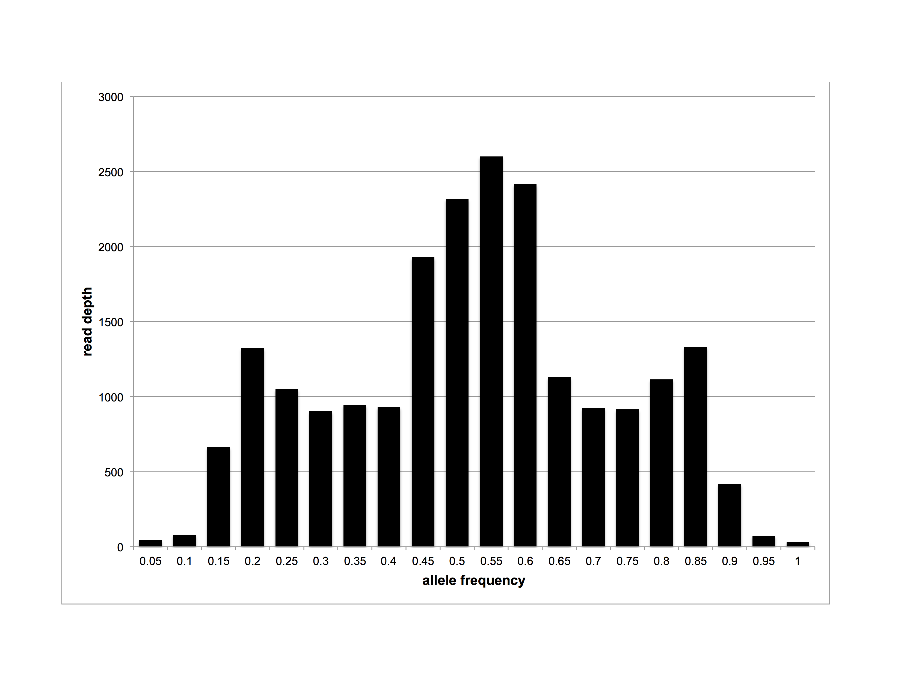

**Fig S5. Distribution of allele frequencies of heterozygous sites across *Blastocystis* ST1 genomic scaffolds.**