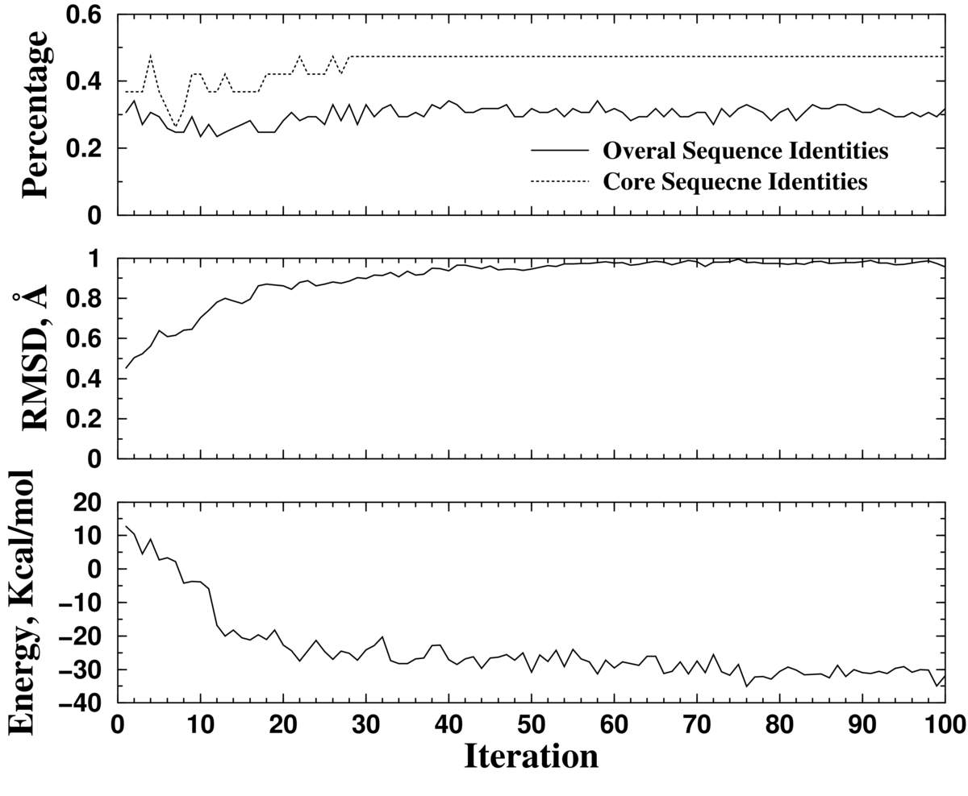
Figure S1. The protein sequence/structure optimization with backbone relaxation. The sequence identities, backbone deviation, and the energy at the end of each iteration are shown.

