School Supply List

**KINDERGARTEN**

* 1 Large Backpack-needs to be able to hold folder
* 1 Over the ear headphones (no earbuds, no bluetooth/wireless please) 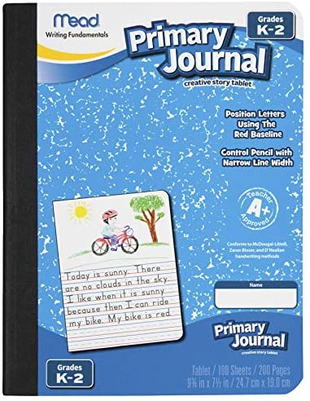
* 1 Primary Writing Journal (go on amazon, type in primary writing journal-needs to have the primary lines and space for them to draw-see picture on the side of this list for an idea of what to look for)
* 4 bx    Crayola Crayons, 24ct
* 2 bx Crayola washable wide markers in classic colors
* 2bx Crayola washable skinny markers in classic colors
* 2 dz    #2 Pencils, Dixon Ticonderoga Preferred
* 3 ea    Large Pink Erasers
* 20 ea  Elmer's Glue, Sticks, Washable
* 1ea    Pencil Box, Plastic 8.25”x5.25”x2”
* 8 ea     Expo Dry Erase Markers, **Black**, **Fine Tip**, Low Odor
* 1 ea Dry Erase Eraser
* 1 ea    Fiskars Scissors 5" blunt tip
* 1 ea     Plastic Folders, 2 pocket, **three prong,**-1 Blue, 1 red, 1 green, 1 yellow-student needs all colors, please make sure folders have prongs
* 2 ea     1" clear view 3 ring binder (one white, one any color)
* 1 ea     Binder pencil pouch
* 3bx     Facial Tissue
* 3 rl      Paper Towel Roll
* 3 ea    Clorox wipes disinfecting
* 1 ea Coloring book for indoor recess
* 1 ea Package of Highlighters (should include yellow, green, blue and pink)
* 2 ea Packages of binder tabs, should have 5 tabs per package
* 1 ea Clipboard-wood preferred

**PLEASE DO NOT WRITE NAME ON ANY SUPPLIES**