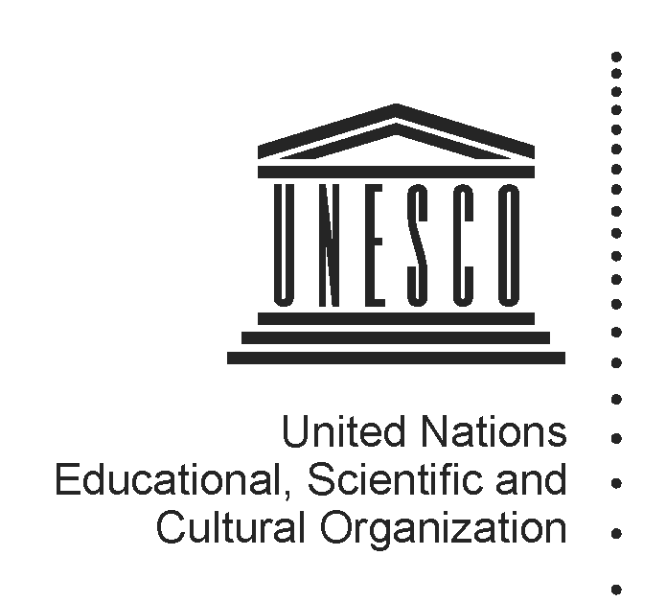 2014-2015
Mapping factsheet
Institutes and centres under the auspices of UNESCO
(Category 2)

Reference documents pertaining to the integrated comprehensive strategy for category 2 institutes and centres:

- 37 C/Resolution 93 (adopted on 19 November 2013)
- 37 C/18 Part I and its attachments
- 37 C/4 (Medium-Term Strategy) and 37 C/5 (Programme and Budget)

Full name of institute/centre and its acronym, if any | International Training and Research Center on the Economics of Culture and World Heritage – ITRECH
Name of the host Member State and city | Italy, Turin
Name of other participating/sponsoring Member State(s)
Date of approval for the creation by the General Conference and relevant resolution | November 2011, 36C Resolution 49
Date of entry into force of the signed agreement with UNESCO | Agreement not signed yet
Date(s) of the renewal of the agreement and relevant Executive Board decision(s) | N/A
Is the present agreement in compliance with the integrated comprehensive strategy (37 C/18 Part I)? | N/A
Duration of the agreement | N/A
Thematic specialization | Economics of heritage, the impact of culture on development, global urbanization and environmental sustainability, cultural diversity and the preservation of the identity of historic cities, and common heritage as a driver of cultural creativity and urban regeneration
Contribution to which UNESCO strategic objectives (37 C/4) and expected results at the main lines of action (MLA) level (37 C/5) | SPO 7: Protecting, promoting and transmitting heritage  MLA 1 – Protecting, conserving, promoting and transmitting culture, heritage and history for dialogue and development (I)
Contribution to the two global priorities of UNESCO – Africa and Gender Equality | Beneficiaries of capacity-building activities to include Africans and equal gender representation.
Contribution to the implementation of sector-specific strategy of interaction with category 2 institutes/centres | World Heritage Capacity Building Strategy (2011); Sector Strategy for category 2 centres (2012)
Implementation strategy (200 words), should come from the agreement | The functions/objectives of the Centre shall be to:  (a) Assist UNESCO in the implementation of the World Heritage Convention and its “culture and development” agenda, by placing special emphasis on the management of World Heritage properties and the field of the economics of culture and urban economic development;  (b) act as a shared platform for training and research activities, exchange and share of experiences and practices, among the various academic and educational actors working in the field of the economics of culture and the management of UNESCO World Heritage properties;  (c) Concentrate its activities on research and higher education on the interrelated topics of the economics of culture, the impact of culture on development, global urbanization and environmental sustainability, cultural diversity and the preservation of the identity of historic cities, and common heritage as a driver of cultural creativity and urban regeneration.
Geographic coverage | Global
Best practices in promoting South-South, North-South and triangular cooperation | N/A
Governing Board | Not established
Financial contributions of UNESCO if the agreement of institute/centre entered into force before 2013 when the General Conference approved the current integrated comprehensive strategy in its 37 C/Resolution 93 | Resources provided under Regular programme for:  (i) feasibility study  (ii) activities, implemented through contractual arrangements  (iii) participation in governing board meetings  (iv) renewal review assessment  (v) others (pls. specify) | N/A
 | Extra-budgetary | N/A
 | Total
 | Centre’s budget and sources of financing | Regular Budget:  Approx. 290,000 Euros  Funding sources:
Has the institute/centre been providing biennial self-assessment progress report(s) to UNESCO?  If so, indicate the date of the last submission and provide the web link | Yes. March 2014  http://whc.unesco.org/en/category2centres/
Has the institute/centre been evaluated and/or audited?  If so, when and by whom? | No
Is the institute/centre considered as non-operational due to the absence of an agreement signed between UNESCO and a host country? | Yes
Responsible UNESCO Programme Sector and its implementing unit(s) | World Heritage Centre  Europe and North America Unit
Name and title of responsible officer(s) | Petya Totcharova (Ms)
Name and title of sectoral focal point(s) for category 2 institutes and centres | Mr Giovanni Boccardi and Mr Frank Proschan
UNESCO field office in contact with institute/centre | Venice Office
Name and title of field office focal point(s) | Veronique Dauge (Ms)
Name and title of UNESCO staff seconded to institute/centre, if any | N/A
Relevant web-links for :
(i) UNESCO sector-specific web-page
(ii) Institute/centre dedicated web-page
(iii) Agreement with UNESCO
(iv) other

