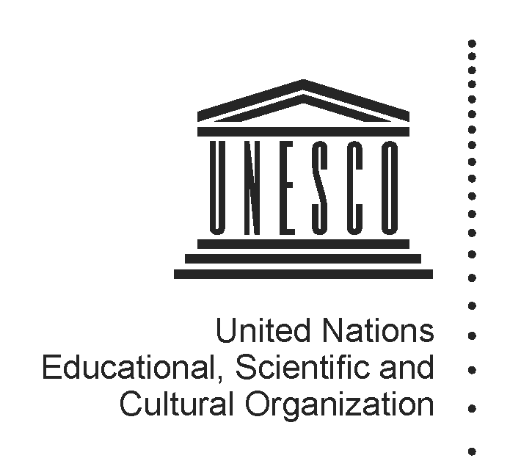 2014-2015
Mapping factsheet
Institutes and centres under the auspices of UNESCO
(Category 2)

Reference documents pertaining to the integrated comprehensive strategy for category 2 institutes and centres:

- 37 C/Resolution 93 (adopted on 19 November 2013)
- 37 C/18 Part I and its attachments
- 37 C/4 (Medium-Term Strategy) and 37 C/5 (Programme and Budget)

Full name of institute/centre and its acronym, if any | International Centre for Rock Art and the World Heritage Convention
Name of the host Member State and city | Spain, Madrid
Name of other participating/sponsoring Member State(s) | N/A
Date of approval for the creation by the General Conference and relevant resolution | November 2011, 36C Resolution 49
Date of entry into force of the signed agreement with UNESCO | Agreement not signed yet
Date(s) of the renewal of the agreement and relevant Executive Board decision(s) | N/A
Is the present agreement in compliance with the integrated comprehensive strategy (37 C/18 Part I)? | N/A
Duration of the agreement | N/A
Thematic specialization | Rock art, conservation, research and management
Contribution to which UNESCO strategic objectives (37 C/4) and expected results at the main lines of action (MLA) level (37 C/5) | SPO 7: Protecting, promoting and transmitting heritage  MLA 1 – Protecting, conserving, promoting and transmitting culture, heritage and history for dialogue and development (I)
Contribution to the two global priorities of UNESCO – Africa and Gender Equality | Beneficiaries of capacity-building activities to include Africans and equal gender representation.
Contribution to the implementation of sector-specific strategy of interaction with category 2 institutes/centres | World Heritage Capacity Building Strategy (2011); Sector Strategy for category 2 centres (2012)
Implementation strategy (200 words), should come from the agreement | Strategic Objective 1:  Generating and disseminating scientific knowledge about rock art and developing specific tools for property conservation and management, with a special focus on the properties inscribed on the World Heritage List and the Tentative List, in addition to properties protected by national laws, by:  • documenting and inventorying the sites and works of World Heritage rock art;  • fostering research on rock art conservation;  • contributing to the improvement of conservation and management of rock art through the training of experts and site managers, generating knowledge and methodological developments and disseminating the above among those involved in rock art by participatory methodologies;  • fostering – in cooperation with the Spanish Agency of International Cooperation and  Development – international cooperation in the identification, reporting and management of rock art, in particular through programmes implemented by UNESCO.  Strategic Objective 2:  Developing strategies and operating tools for the implementation of the World Heritage  Convention for the management and preservation of properties, by:  • contributing to reinforce capacities for the application of the World Heritage Convention  at rock art sites;  • contributing to the enhancement of conservation, safeguarding and management of  cultural and natural heritage through education, knowledge and methodological progress and by developing activities to strengthen management and conservation skills;  • cooperating with the World Heritage Centre and the secretariats of other UNESCO cultural conventions related to heritage;  • contributing to the creation and dissemination of information on the application of the World Heritage Convention;  • helping youth discover and appreciate heritage and participate in its conservation and  dissemination, in line with the objectives and general guidelines of the UNESCO programme “Heritage in Young Hands”;
Geographic coverage | Global
Best practices in promoting South-South, North-South and triangular cooperation | N/A
Governing Board | Not established
Financial contributions of UNESCO if the agreement of institute/centre entered into force before 2013 when the General Conference approved the current integrated comprehensive strategy in its 37 C/Resolution 93 | Resources provided under Regular programme for:  (i) feasibility study  (ii) activities, implemented through contractual arrangements  (iii) participation in governing board meetings  (iv) renewal review assessment  (v) others (pls. specify) | N/A
 | Extra-budgetary | N/A
 | Total
 | Centre’s budget and sources of financing | Regular Budget:  An allocation from the State budget of 4,456,000 Euros  was foreseen for the first three years of operation of the  Centre.  Funding sources:
Has the institute/centre been providing biennial self-assessment progress report(s) to UNESCO?  If so, indicate the date of the last submission and provide the web link | Yes. March 2014  http://whc.unesco.org/en/category2centres/
Has the institute/centre been evaluated and/or audited?  If so, when and by whom? | No
Is the institute/centre considered as non-operational due to the absence of an agreement signed between UNESCO and a host country? | Yes
Responsible UNESCO Programme Sector and its implementing unit(s) | World Heritage Centre  Europe and North America Unit
Name and title of responsible officer(s) | Dr Nuria Sanz
Name and title of sectoral focal point(s) for category 2 institutes and centres | Mr Giovanni Boccardi and Mr Frank Proschan
UNESCO field office in contact with institute/centre | N/A
Name and title of field office focal point(s) | N/A
Name and title of UNESCO staff seconded to institute/centre, if any | N/A
Relevant web-links for :  (i) UNESCO sector-specific web-page  (ii) Institute/centre dedicated web-page  (iii) Agreement with UNESCO  (iv) other | None

